Assignment - 2
1. Chatter groups are the best way to communicate with customers and employees. Create a chatter group, and perform the following operations:
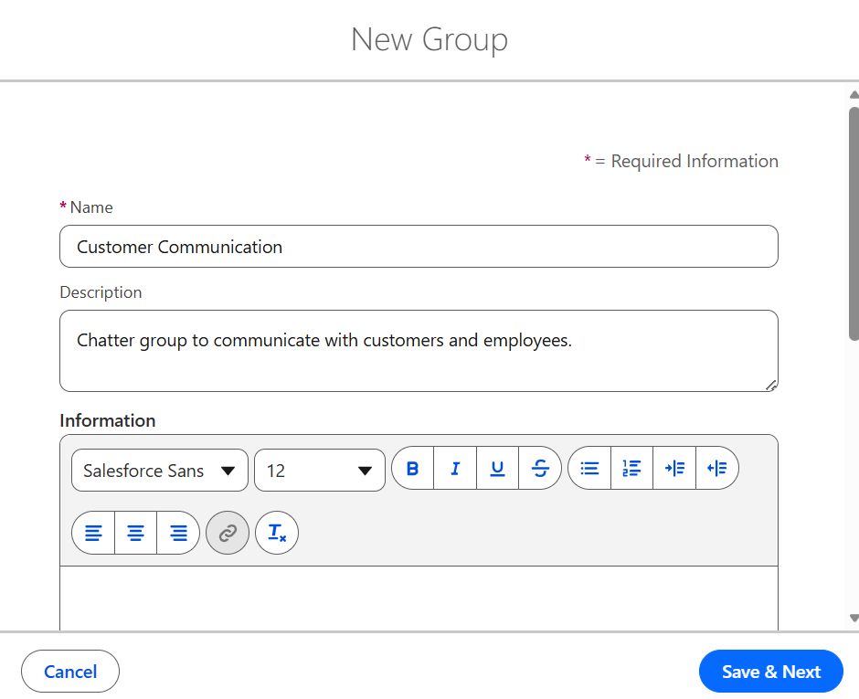
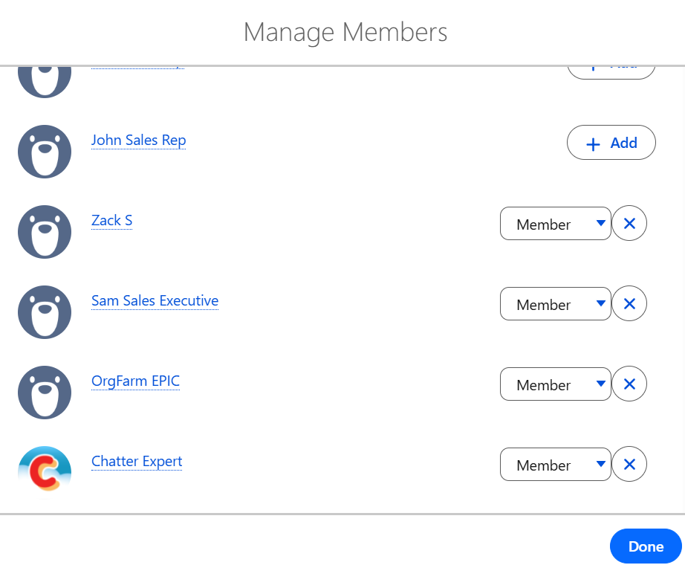
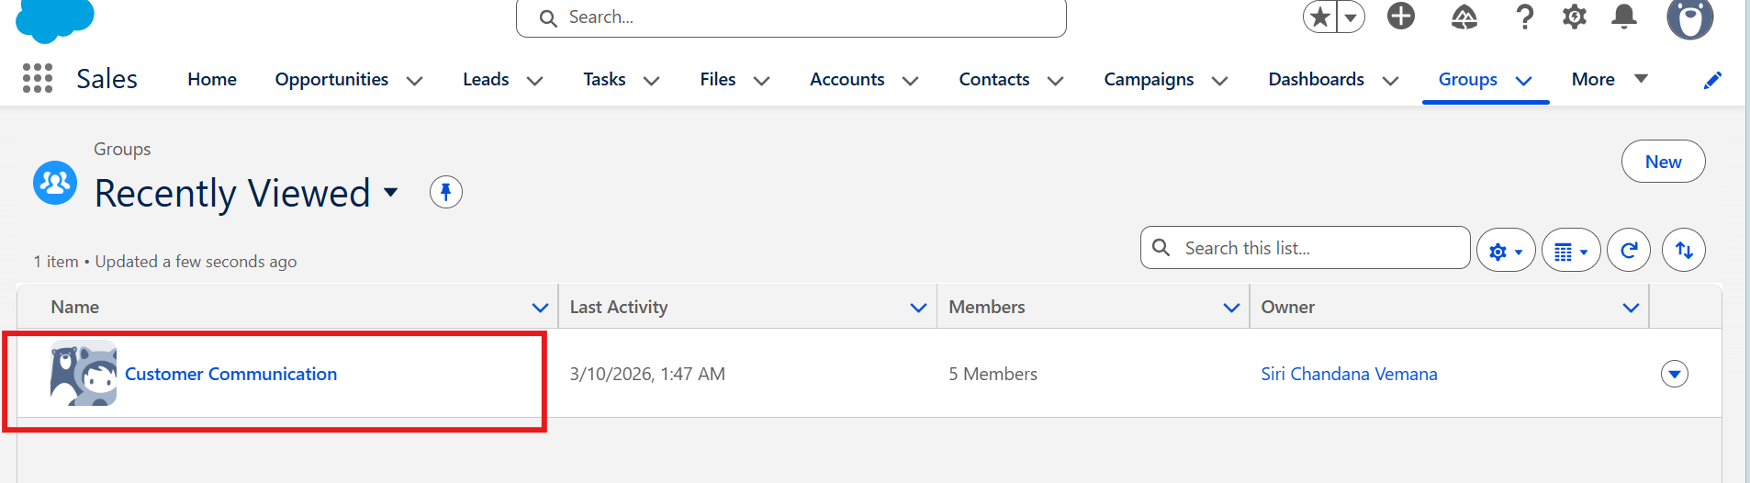

a. Enable Feed tracking for your group to track updates and changes
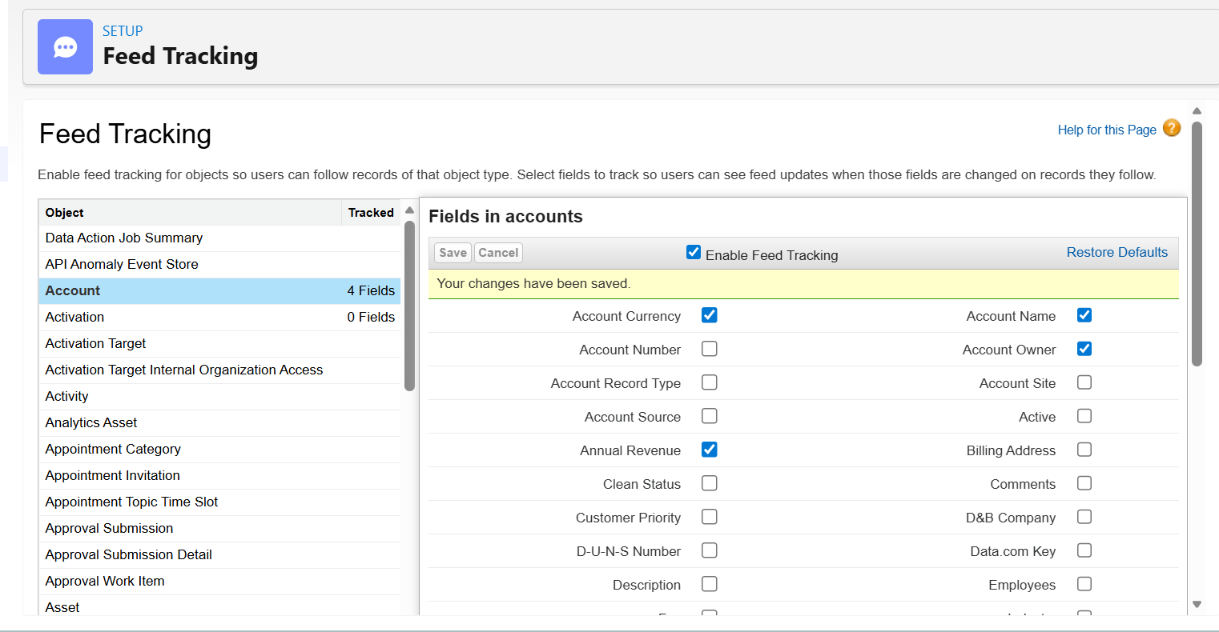
b. Create a Chatter Free user
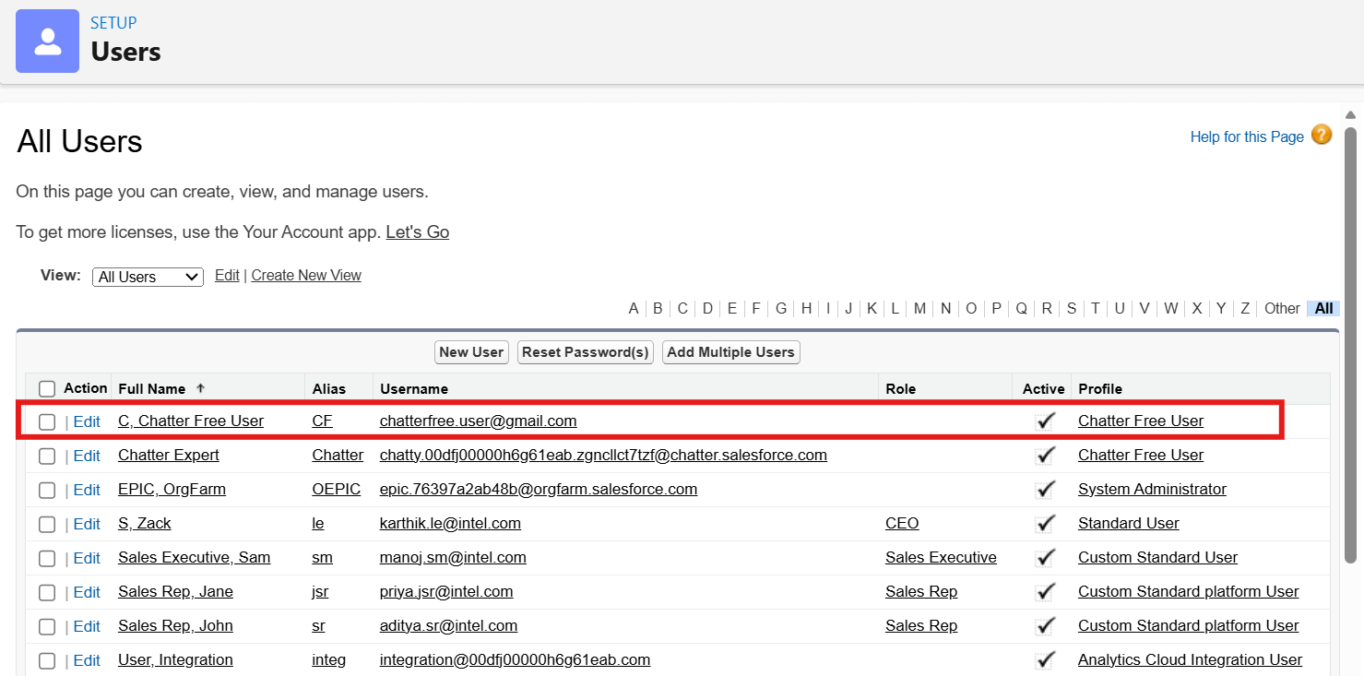

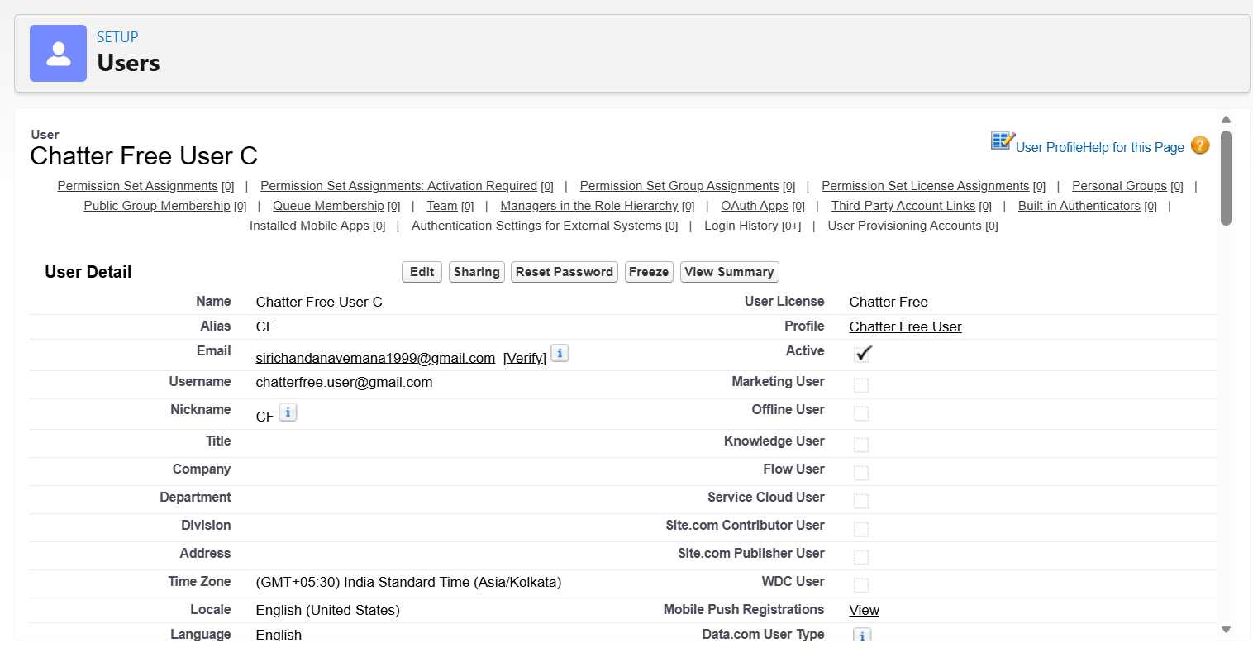

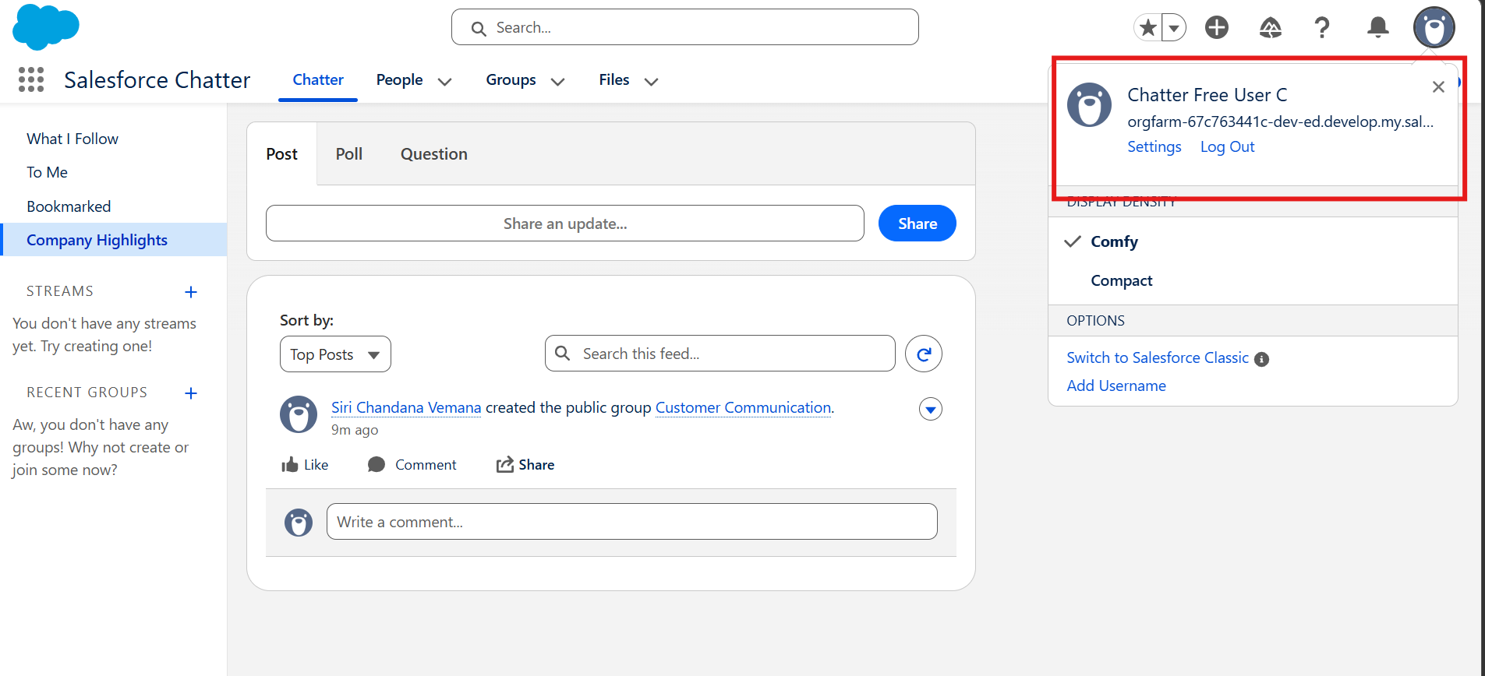
c. Customize Chatter email notification
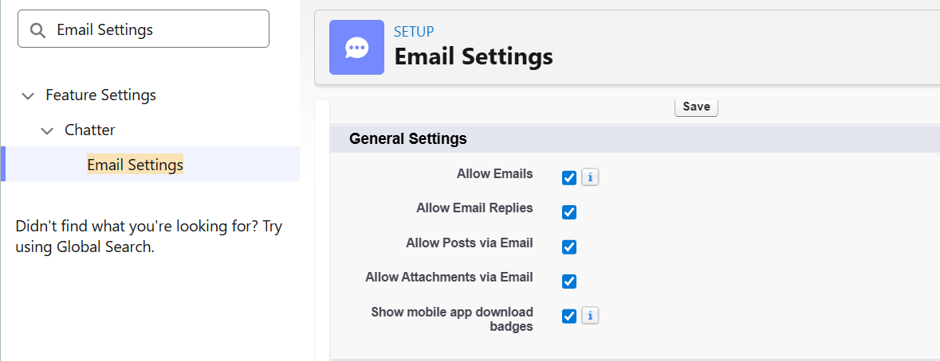
d. Modify the settings so that the user can get all email notifications
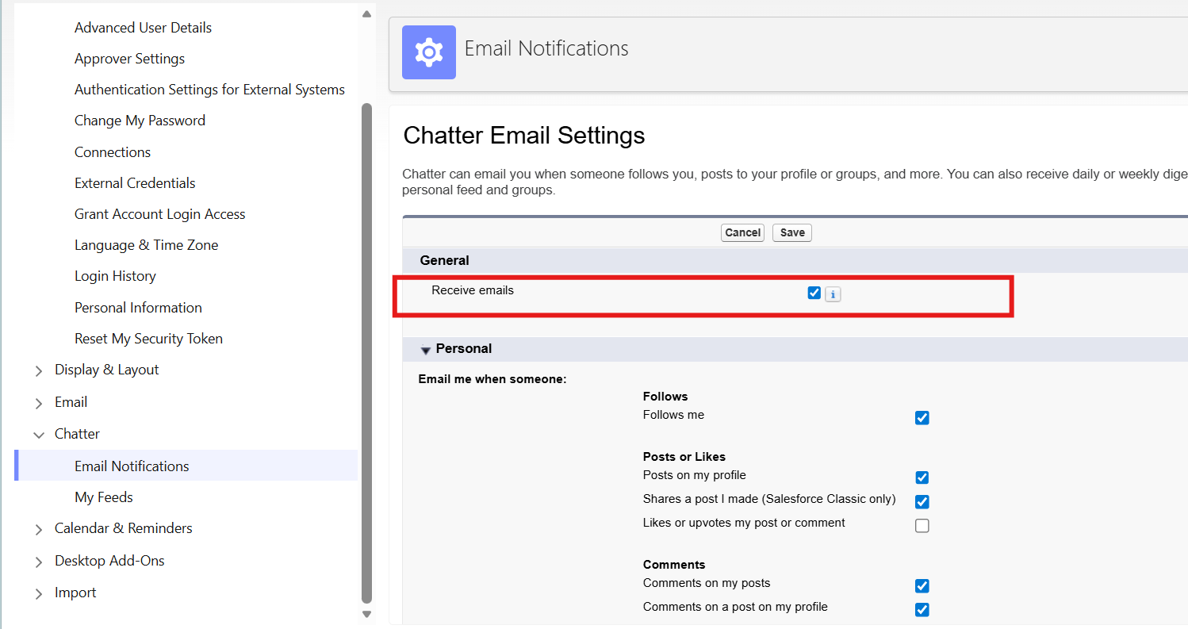

e. Modify the settings so that the user can see the comments on his/her post
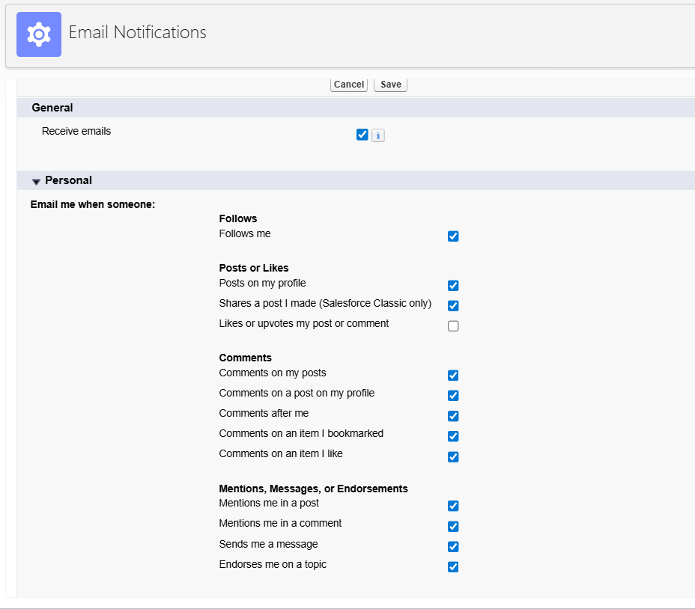

f. Set the frequency for personal digest as ‘Weekly’
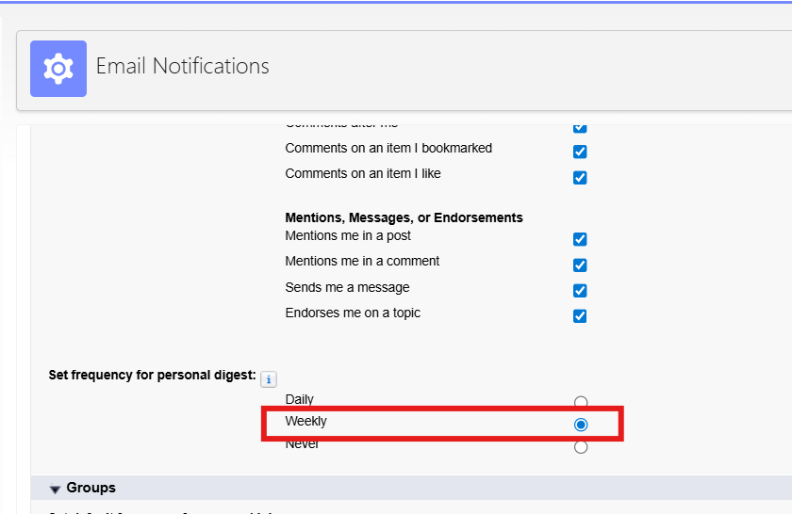
g. Create a CSV file, and share it with other Chatter group members.
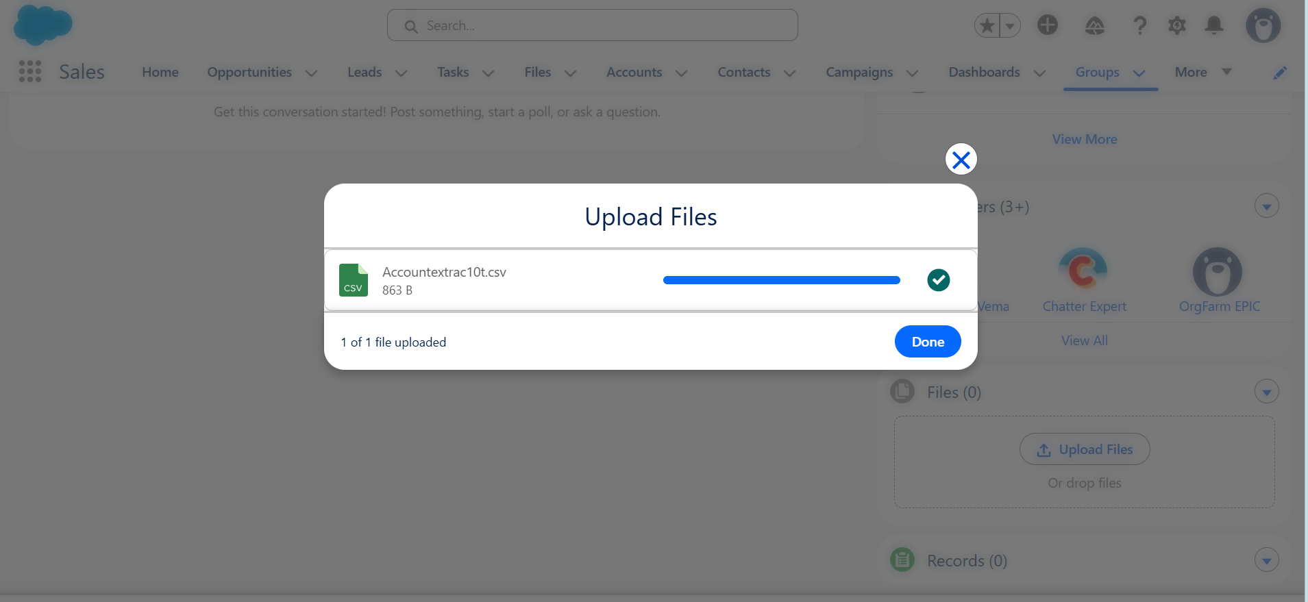
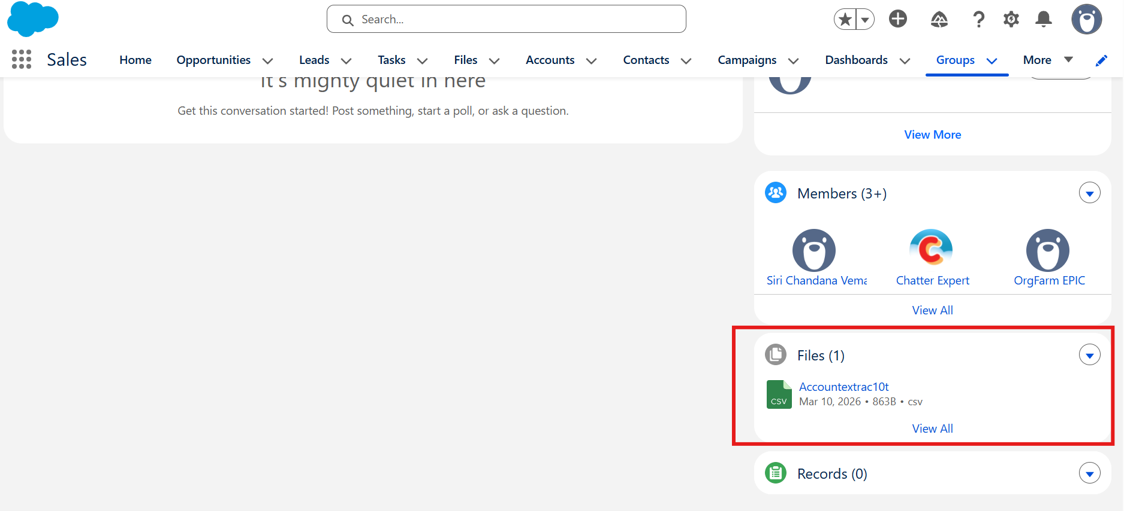
2. Create a custom object as per the following conditions:
a. Give the name ‘New Course’
b. Set the data type as ‘Auto Number’
c. Display the format as ‘C-{00}’
d. Set the starting number as ‘1’
e. Enable all optional features
